Otago Polytechnic
Wrench mask
[Document subtitle]
Rachel Wheeler
[Date]

Contents
Introduction and Explanation of Project. 1
User Stories. 2
Basic Research. 3
Hardware Used. 4
Insights and Discoveries. 5

Introduction and Explanation of Project.
Write about half a page.

Explain how you came to design and build your project. What is the original inspiration for this project? Why does this topic matter to you. This section can be finished last if necessary

The original inspiration for this project was the character Wrench from the game Watchdogs 2, I wanted his mask since I first saw the trailer for the game many a year ago. Faces other than my own are especially interesting to me as I already wear the wrong one, so masks like this are a way to present a more correct one to the world. As such they are very important to me.

In order to design this mask I found a mask base, knew I wanted it to be voice variable so it needed a mic module, screens with a wide view angle and brightness, so a couple of OLED screens for eyes. Beyond the aesthetic requirements, the Arduino uno does not have enough computing power or RAM to be able to display images at the size, resolution, or number that I require for this project so Instead I will be using the Teensy 4.1, which my research identified as a standard for wearable projects due to it’s light weight and low power consumption but excellent computing power and huge increase in ram over the uno or an esp32.

User Stories.
Write about half a page.

Write as many user stories as you can to support your project. It would be ok to have user stories that don’t get implemented (But maybe explain why).

Once you’ve done that, define some use cases or functionality that will support the user stories you have chosen to implement.

The correct format is:

As a [type of user] I want to [describe need] so that I can [reason]

As a [cosplayer] I want to [portray my favorite character in an accurate way] so that I can [win my next cosplay comp]

As a [cosplayer] I want to [be able to move it around] so that I can [walk around a con without carrying a big thing]

As a [buyer] I want to [be durable enough to survive shipping and transport] so that I [don’t have to fix it]

As a [content creator] I want to [be able to film it without issue] so that I can [make a video without needing to worry about screens refreshing at a strobing rate with the camera ]

Remember user stories don’t provide technical solutions!

This answers the basic question of “who” is a user of your project.

Basic Research.
Write about a page.

You should preface all work with some form of simple research. The goal of this is to be able to make informed decisions and justify choices that you have made for your project.

This can be checking for sensors or devices from a range of suppliers based on features, simple comparison of software, etc. You can also discuss some of the wider issues that might exist in the problem domain, what is in scope and out of scope (and why you think so).

The point of this is to answer the question of “why”. Why did you choose these components, why you did your project this way and not another, why your project is a good solution to the problem, etc…

The major place of research was around the microcontroller in the first place. The Arduino Uno does not have the ram or processing power to be able to operate the components I knew I was going to need, that being a pair of larger screens and at a more wearable scale. The question then became whether or not I should stay within the Arduino sphere or try other microcontrollers. I found that if I wanted an Arduino with the minimum specs I needed it would then be basically a raspberry pi and the boot time and weight would become uncomfortable. That left me with an ESP32 or the Teensy 4.1. Both have advantages over the other, The ESP32 would give me access to Bluetooth and WIFI, this would allow me to experiment with remote control functionality while being able to store and process several images at the general size I could expect. The teensy 4.1 on the other hand has waaay more memory than the esp32, teensy has 8mb while esp has 4mb at standard (modules can have more), it also has native drivers and libraries optimised for screen and LED control with a small wearable formfactor. This allows me to have multiple images at a higher resolution than v1 and enough memory to be able to implement short video sequences if I so wish at a later time but no WIFI or BLUETOOTH connectivity.
I ended up going with the Teensy over the esp because it has that large memory by default, and recommendation from other industry and costuming peoples who use it in wearable systems.

I also had to find screens to fit in the mask, were bright and had a wide view angle in order to make sure the eyes were high enough resolution to display whatever I may wish at a clearer resolution and scale. Thankfully the mask was already printed so I measured the inside of the visor and determined that a 2 inch display would be ideal size. Now turns out there is only really one oled screen at that size that can communicate with a microcontroller, so I picked that one as it also checked every box (resolution, view angle, brightness) It also proved better than the smaller mono colour screens in the v1 due to the fact that they are cheaper, and have full rgb colour as well. The biggest issue that both have is SPI communication, which I later learned only works across a distance of about 20-30 cm

Hardware Used.
Write more than one page. Include relevant pictures with explanation.

List and justify your hardware choices here. Explain how these fulfil the requirements of your project, how they will implement use-cases based on your user stories.

Explain to me how your project is put together. Use lots of clear relevant pictures, making sure they have an explanation about what they are showing.

Use this section to provide one or more clear diagrams of the layout of your components in your project.

List the technical requirements your project has implemented (See assessment instructions)

I should be able to use this section to follow along and build your project from scratch.

This answers the basic questions of “what” and “how”

Hardware Components:

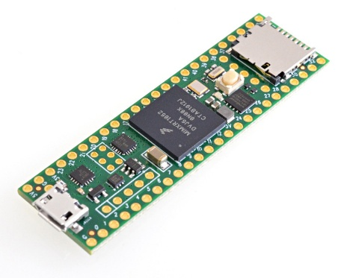

- Teensy 4.1: the teensy was chosen because of it’s great computing power and ram with minimal power draw and very light weight as well as optimised systems for wearable costuming with LED or screen components according to my research.
It’s lightweight form also allows it to very clearly meed my second user story of comfortable wearability

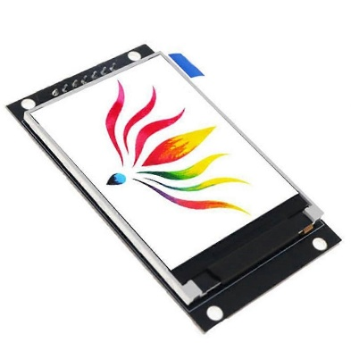x2
- TFT Display 2.0 Inch OLED LCD Drive IC ST7789V 240RGBx320 Dot-Matrix SPI Interface for Arduino Full Color LCD Display: that is the full name of this component apparently, It is essentially a cheap 2” display that can interface with the teensy, it was chosen because I needed a 2 inch OLED display that could be mounted easily, this is the only option I could find that didn’t have extra expense from a touchscreen interface and the sort of resolution I wanted in order to display cleaner / more varied images. It also doesn’t constantly refresh so it meets the last user story by not having a strobe effect on video.

NEED 2 OF THE SCREENS

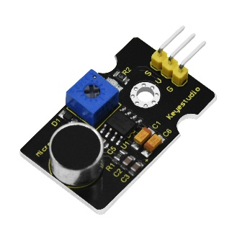
- Keystone studio Microphone Sound Sensor Module: NOT REQUIRED FOR CURRENT VERSION, used to make screens volume variable in order to facilitate a reactive product – currently nonfunctional due to unforeseen error or incompatibility with the teensy
- Replace above with standard 3 pin potentiometer in order to replicate the expected signal output

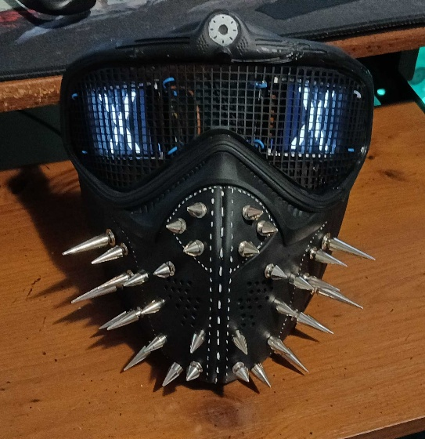

- Mask: Now this part is not purchasable as a real world object but is still an integral part of the hardware and is crucial for the first and third user stories, now I chose a 3d printed version because while the time to make it is greater than if I were to purchase a similar product like an airsoft mask, It is far easier to customise and certain required aspects for a true representation of wrench such as the fake white light at the top of the mask would be a nightmare to implement. As such there is a bit of a shopping list in order to acquire this part.

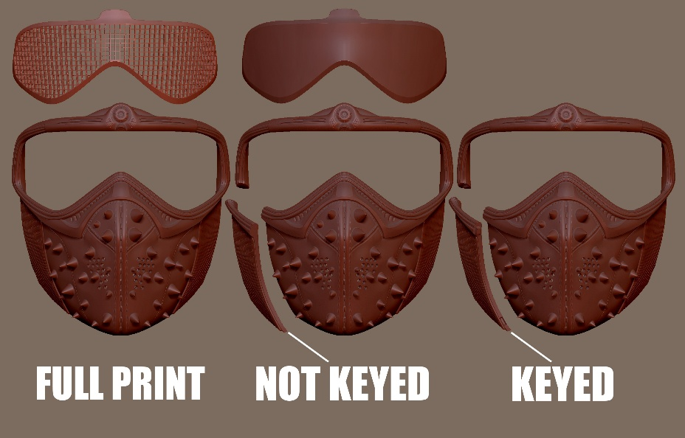
- The base: The base is this → https://cults3d.com/en/3d-model/art/wrench-from-watchdogs-3d-print-mask, a 3d file taken from the game and altered for printability by user TOUCI on cults. In order to make sure that the print is strong enough and detailed enough for use make sure to print in resin if possible or at a low layer height in a tough material on a fdm printer. As there are options of files that include the spikes you can use those versions if you don’t want to use real spiked studs but I’d recommend against them as you also lose lots of attachment sites on the inside that makes any mounting of non screen components easier if you wish to do so.
If you do wish to use real spikes see next otherwise you are good to skip.

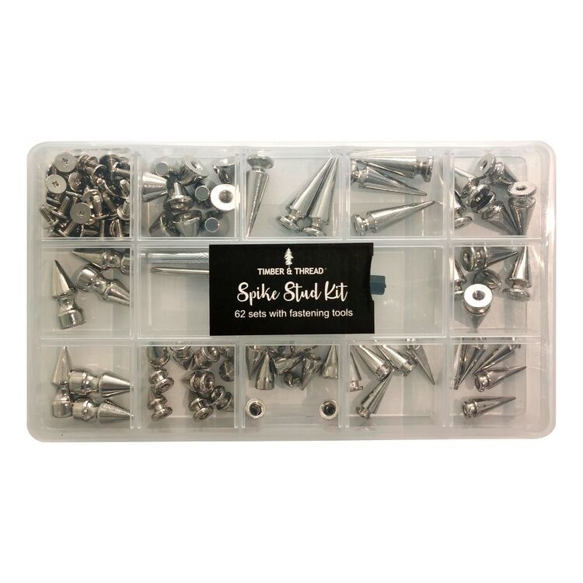
- Spikes: now for true accuracy you should be using screw back spiked studs that are a cone or bullet shape all the way down, but really any screw back spikes are acceptable and up to artistic choice on your part. For convenience sake I chose to use this kit from spotlight but this specific kit is by no means required.
It is important to note that standard screws for these types of spiked studs are standard m3 screw thickness and intended for thinner surfaces than all the parts of the mask will allow, so you also need to pick up some 8, 10, 12 mm long m3 screws as needed to ensure a secure hold across all spikes across the mask. These can be acquired at Jaycar as they happen to be identical to the m3 screws used to secure electronic components.
NEED 30 SPIKES FOR WHOLE MASK!

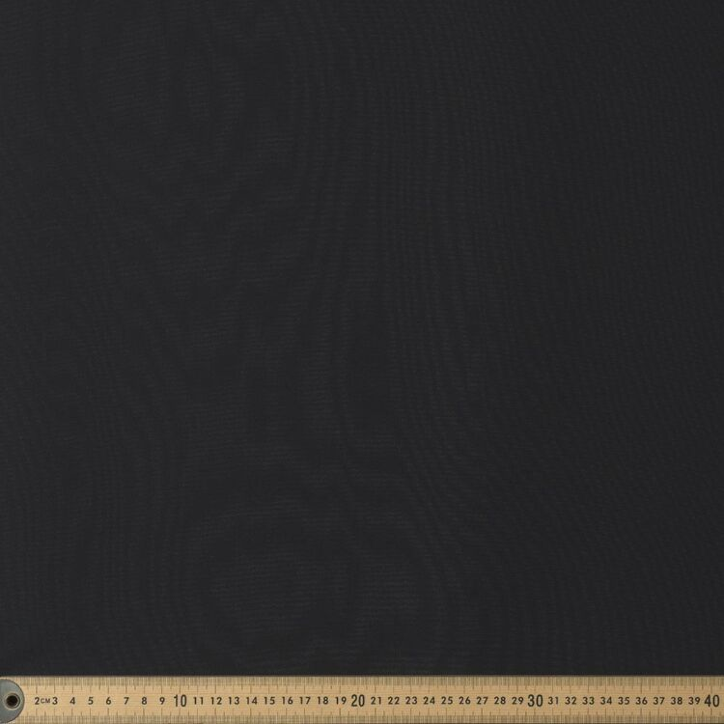
- Mask visor backing: any black fabric that is transparent enough to see through, I used black Chiffon for it’s clarity when seen through but dark black when viewed from distance, but many different kinds will work just as well

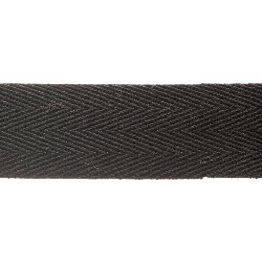 x 2m
- Straps for mask: many materials will work as long as they are 20mm wide and have zero stretch, the mask has enough weight that any elastic in the straps will fail quickly rendering them useless and uncomfortable. I used 20mm black cotton heading tape because of it’s complete lack of stretch and availability, ideal would be 20mm polyester webbing most likely. You will need around 2m minimum to be safe

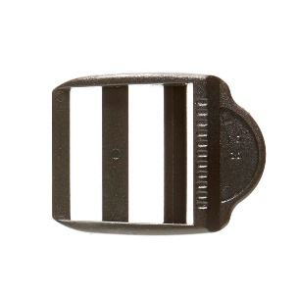
- Buckles: I used birch 20mm adjustable buckles, any black adjustable 20mm buckle will do, just need to make sure the straps cannot shift when in use

- Power: use a phone power bank as power source, make sure it doesn’t try to force too high of an amperage through the teensy and you should be fine for long periods

- Misc:

Black primer – use filler primer sparingly then sand for smooth finish if layer lines too visible.
Chosen colour of acrylic hobby paint for stitching, yes it has to be hobby paint, if you try others they are either too thick to use or wont adhere properly. I used Army painter mummy robes mixed with a little pure white to give a nice warm cream colour, as well as some black hobby paint that matches your primer for spot fixes.
Black twistable wire to mount screens.
Standard detail thickness model painter brush.
Spray varnish and degloss – optional.
Lots of superglue.
Roughly 20 male to female wires, recommend multiple colours / this set from Jaycar https://www.jaycar.co.nz/150mm-plug-to-socket-jumper-leads-40-pieces/p/WC6028

ASSEMBLY:

- Build the mask base:

The first and most time consuming part is to build the mask, I had to print mine in several parts due to the small size of my print bed, you can also get the full mask with holes for the spikes printed as a single piece by any number of print shops to a high quality, but that will cost over 100 dollars to do so +gst and shipping from any place I got a quote from, such as this one 
So this step will vary depending on how you go about it but all you have to do is this ↓↓↓
GOAL IS TO GET MASK BASE TO PAINTABLE STATE!\

Once that is done simply prime the mask with the black spray primer of choice, making sure to hit all the visible surfaces, even if that requires painting parts of the inside. NOTE: only use filler primer if you have very visible layer lines, be sure to sand after priming to get rid of them before moving on.

Then take your selected colour of hobby paint and your brush and very carefully paint the stitching around the faceplate of the mask, you can use the black hobby paint to clean up mistakes afterwards if needed.

Finally take your spikes, lay them out in a pattern you like if using variable lengths or styles and make sure they match up with the holes on the mask and install them now. This step can be a little fiddly and it is easier to remove and replace a single spike later if needed than it is to negotiate the 30 odd spikes later.

- Assemble the circuit:
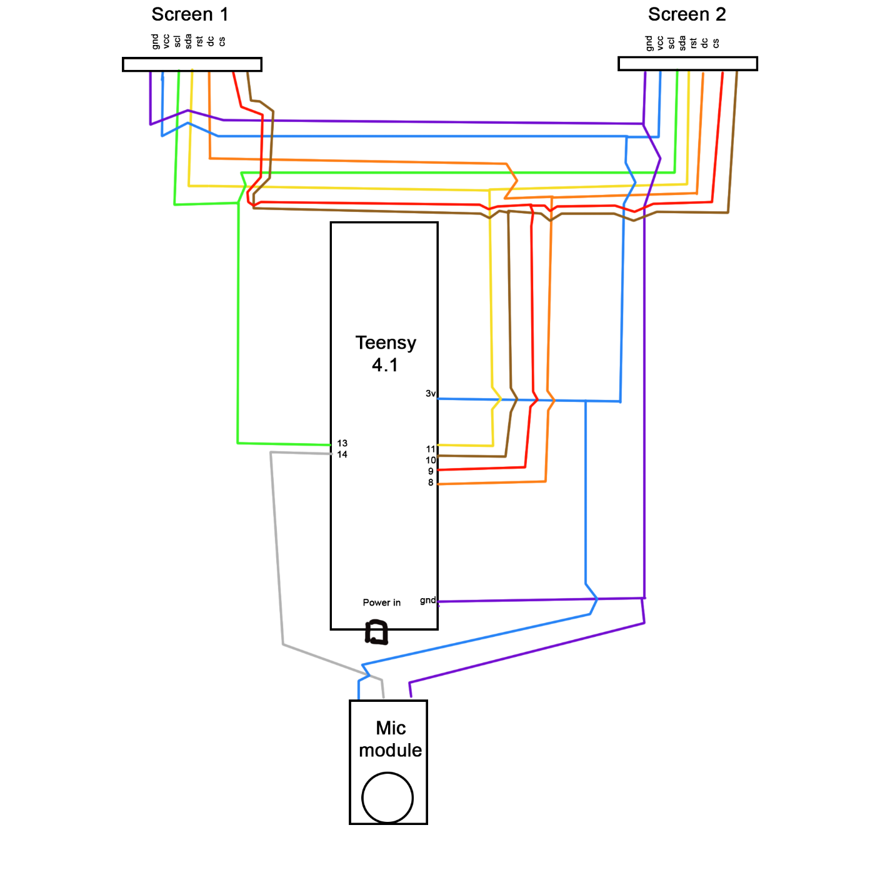
- Assemble the circuit as depicted above, try with mic but if need be use the other set of code using the potentiometer, I have colour coded the circuit in hope of aiding as I know it is rather confusing to look at.
Once that Is working solder it together making sure that the screens and mic/potentiometer are still detachable

- Assemble final thing:
After this it’s as simple as just put everything in the mask, make sure the screens are positioned with the pins facing outward and aligned to the outer edge, you may first want to bend the pins on each screen so that they do no face into the centre of the mask and instead face outwards allowing more room for the face to fit. This does mean that one screen is technically upside down but as long as the images you show are mirrorable top and bottom that will be fine
Wire the corners of the screens into the mesh visor very very gently, you just want tight enough that it wont shift, then use superglue on the twists of wire to keep them from shifting.
cut a slightly oversized portion of the backing cloth and attach to inside of the visor area, there should be plenty of fabric overhanging, this allows for the chance to realign or not be as tight to the measurements as possible, all that matters is making sure that the whole back of the visor is screened. You may use what you like to attach the cloth, I used superglue, something like hot glue or other methods may work better.
Trim away the excess fabric and cut two small holes for the wires to plug back into your screens
Place your soldered pcb into the mask and plug back into screens and mic, you can use the screws from the spikes to hold it in place directly or attach wires to them and use those to hold it. I have left it free swinging for ease of tinkering
Test all is working as intended
If yes start on the straps, cut short lengths for one side top and bottom straps to hold the buckles and another 2 lengths – (measure your head + ease allowance to find length) for the other side. Sew in the shorter lengths + buckles through the left top and bottom holes, then sew in the longer lengths for the right.

- Wear it!
You should now have a wearable Wrench cosplay mask, congratulations!

Technical requirements met:

There are two versions of my code, the one for presentation and the other that I have not had time to get working, being the mic version

Both have:
- Analog inputs
- Arrays
- Specialised communication – spi to screens
- External hardware
- Soldered circuit
- Perhaps specialised functions (using the tft commands to control the displays)

The not quite working as needed version (03_variable_eyes_slightly_cleaned.ino) adds
- Specialised functions for sure by suing millis
- Attempts pulse width modulation by measuring the height of peaks (amplitude) of sound in order to get an actionable volume level, other methods of doing so including just reading the input of the mic has proved non functional at all

Insights and Discoveries.
Write about half a page.

Finally, some reflection and self-analysis. Appraise your work, tell me about any insights you have gained from this, what you would do differently, what you particularly liked about your solution, etc.

I think over all this project has worked out well as far as making something that would be perfect for cosplay goes, I can change the eyes at will, even if it is just with the potentiometer, it looks perfect, and it consistently gets the correct reaction (“woah that thing is so cool!”). But I had to compromise on a lot of things and change my vision many times to get even to this state.

Initially I wanted to have he controller at the belt with wires going up my back to do all the things, that way I didn’t have to have everything in the mask and would be much more comfortable, but as I experimented with the cable lengths and making cables of different lengths and different materials I discovered that I was limited by the SPI communication protocol. That limit being that it can only travel over about 20-30cm max, which I discovered by spending waaaay too much time making those wires, so I had to move it into the mask.

Secondly if I were doing this again I would have tackled the mic issue sooner, my first mic died so I had to wait to get another, that wait has probably cost me the ability to make this version volume modular, but as I have tried to fix this I have found that Teensy has an audio processing library, and I think that can do things like frequency and volume, but I do not have time to dive into it and explore, and I think I may need a different kind of mic module for it as well, that being a proper microphone, which I do not have. I do want to experiment with that at some point in my own time later and see if I cant get this thing to respond to pitch and tone, giving me way more control at some later date, but that is unfortunately way out of my time and scope for this project.

All in all I love how it looks, I will certainly be using it for it’s intended purpose next chance I get, It is more than useable enough in it’s current state even if not where I want, and I know I can always improve on it in so many ways. Be that by adding a Bluetooth control or app integration by adding a wifi mod to the teensy and having it connected to my phone, or by adding more physical sensing media, like a small switch on the inside that detects when I am cocking my head to have an interrupt that does a questioning expression for example.

I am no where near done, but I am going to have to be done enough for this assessment.

